马格南多媒体影像创作营申请表
Application Form for Magnum Multimedia Creation Camp
2018.3.22 - 2018.9.19

欢迎加入马格南首个多媒体影像创作营的课程，
您将在马格南华裔摄影师张乾琦的指导下，展开一次充实的多媒体影像创作之旅，加入我们吧！
请在2018年3月11日晚上9点前提交申请。

Join us for the Magnum’s first Multimedia Creation Camp
with the renowned Magnum Chinese American photographer Chien-Chi Chang!
Please submit your application by 9 pm March. 11th 2018.

•姓名／Name
名／First 姓／Last
•国籍／Nationality
•性别／Gender
•年龄／Age
•邮箱／Email
•地址／Address
•国家邮政编码 ／Postal / Zip Code Country
•电话／Phone
•个人微信账号 ／Wechat
•个人网页 （可选填）／Web Site ,Optional
•摄影经验 ／Experience of Photography
□1-2年/Years □3-4年/Years □4-6年/Years □6年以上/Above 6 Years
•多媒体创作经验／Experience of Multimedia Creation
□1年/Year □2年/Years □3年/Years □4年以上/Above 4 Years
•个人陈述／Personal Statement

•请填写您的摄影经历和对此次创作营的期望。
Please write about your experience of photography and multimedia creation, and your expectations for this Creation Camp.
•作品提交／Submit Your Work：
请连同报名表和一组15张以内的相片或一部原创影片发到报名邮箱workshop@dakenart.com中，同时交纳人民币800元作为申请定金。作品需附文字介绍，图片文件须为JPEG格式，每张大小不超过200kb，视频文件须为500MB以内，以及MP4、RMVB、AVI、MOV等常用格式。报名申请截止时间为2018年3月11日晚上9点。
Please send a group of fifteen images or one original video work at most of your project with the application form to workshop@dakenart.com，and at the same time pay the 100 GBP as the application deposit. The images must be in JPEG format and no more than 200kb each, and the video should not last bigger than 500MB and in MP4, RMVB, AVI, and MOV…etc. And please add your project description. The deadline of the application will be on 9 pm March. 11th, 2018.
•您从什么途径得知此次创作营？ ／Where did you hear about this event?
•你的支付方式及账号／Your Payment and account number

支付、取消和退款／Payment, Cancellations & Refunds
- 创作营申请定金为人民币800元／人。学费为人民币26,800元／人，学费不包含食宿及差旅费。被录取者只需支付除定金外的剩余费用即人民币26,000元，未被录取者将收到申请定金的全额退款。
The application deposit is 100 GBP per person. And the tuition fee is 3,000 GBP per person（not including the cost of travel, food and accommodation）. The selected persons should submit the rest tuition of 2,900 GBP, and for the unselected persons, the application fee will be returned.
- 创作营导师将以作品为基准审核您的申请，通过审核申请的学员将会收到录取邮件及确认电话。未通过审核申请的学员将会收到邮件通知，以及申请定金的全额退款。
The Magnum photographers in this Creation Camp will look through your applications based on the your works，and the applicants who pass will get the email and confirm call. The applicants who fail the application will receive e-mail and a full refund of the application deposit.
- 定金与学费的可选支付方式包括支付宝、银行转账及PayPal，为保证统计的正确性，请在转账时备注您的姓名。务必在确认被录取后再支付全额学费，以免造成不必要的误解。若未及时支付申请定金，您的申请将无法受理。如有问题，请联系我们：workshop@dakenart.com。
The method of payment about the application deposit and the rest tuition includes: AliPay ,bank transfer,PayPal. Please write your name in the remarks in order to making sure of the correct statistics. The applicants should pay the rest tuition fees after receiving the selected notice, lest there be some unnecessary misunderstandings. Please note your application cannot be processed without an application deposit fee. If there is any problem, please contact us: workshop@dakenart.com.
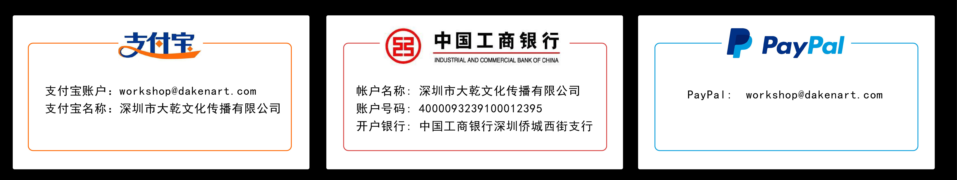
- 报名申请截止时间为2018年3月11日，全部学费须在2018年3月15日之前到账。
The deadline of the application will be on Mar. 11th, 2018, and full tuition fees should be received by Mar. 15 th 2018.
- 若已通过审核的学员需取消报名，在2018年3月15日前申请退款，将扣除人民币800 元的审核管理费；在创作营正式开始（即2018年3月22日）前，申请退款，将扣除50%已交纳的学费；在创作营开始(即2018年3月22日)后，学员因个人原因需要退出的，主办方不予退还任何费用。
If the applicants who have passed the application require to cancel it before Mar. 15st 2018, we will deduct the audit expenses of 100 GBP and return the rest refund. Before Mar. 22 th 2017, 50% of the paid tuition will be deducted; after Mar. 15 th 2017, the organizers will not refund any fees.
- 在少于8名参与者的情况下，主办方保留取消创作营的权力。学生将获得全额退款或得到参加玛格南工作坊其他站点活动的机会。如工作坊取消，学生将至少提前1周收到通知。对于国际申请者，若工作坊取消，主办方将不予退还任何差旅费用，因此我们郑重建议您购买可退还车票或者旅游保险。
The organizers reserve the right of canceling this Creation Camp under the circumstance that there are less than 8 participating students, and the students will be given a full refund or an opportunity joining in other Magnum Creation Camp. If we decide to cancel, the students would be noticed at least 1 week in advance. For the international applicants, if the workshop were canceled, the organizers would not be responsible to return any travel expenses. Therefor, we highly recommend that you should buy the refundable tickets and/or travel insurance.
- 主办方对该课程项目保有最终解释权。
The workshop organizers reserved the right of final explanation to change or alter the program advertised.
- 申请提交后则表示您同意以上条款和条件。
It means you agree on these terms and conditions by submitting your application.

